

**Vol. 1, Issue 1 (2025)**

**Definition of a Smart City According to the Malaysia Smart City Framework (RKBPM):**

“Cities that utilize **information and communication technology (ICT)** and advanced technologies to address urban issues, enhance quality of life, promote economic growth, develop a sustainable and safe environment, and encourage efficient urban management practices.”

(**Source:** *RKBPM, Chapter 2 - Smart City Framework, pg.16*)

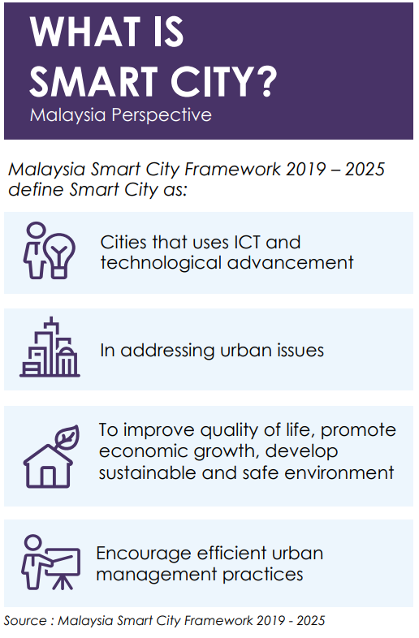

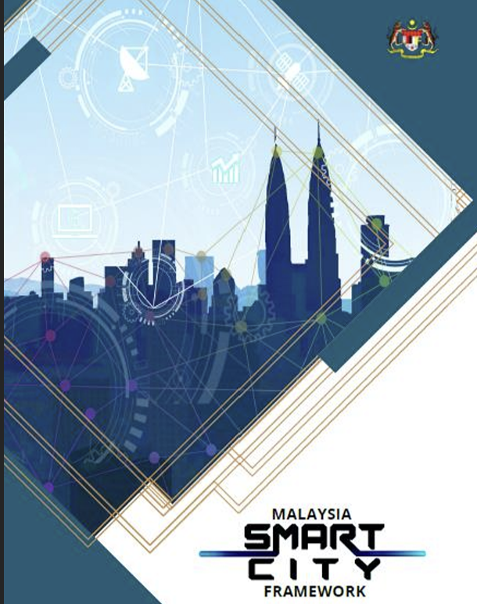

**7 major components of smart city Malaysia**

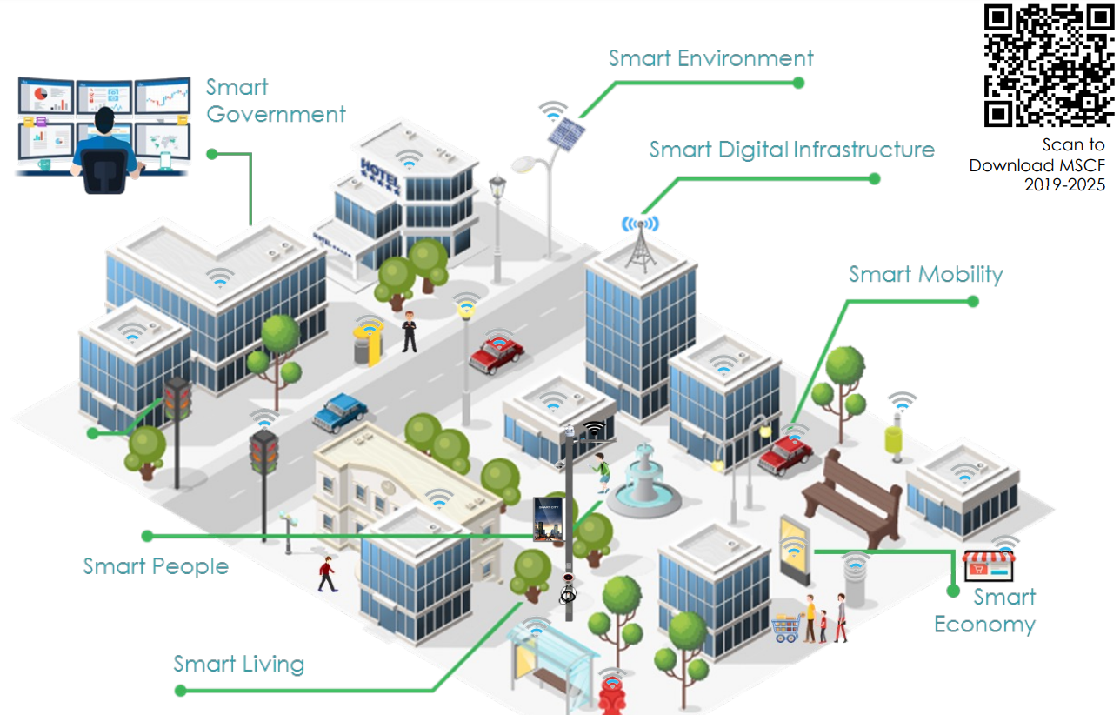

**Smart Cities: A New Approach to Urban Management in Malaysia**

Smart cities are seen as a new approach to **urban management and development**, aimed at making cities in Malaysia more sustainable and livable. At the same time, advancements in technology and the increasing use of **information technology (IT)** have made the smart city approach more practical, facilitating both residents and urban managers.

In this regard, the **Malaysia Smart City Framework (RKBPM)** 2019-2025, developed by the **Ministry of Housing and Local Government (KPKT)**, serves as a key national reference for the planning and development of smart cities in Malaysia. The framework acts as a specific guide for local authorities (PBT), state authorities (PBN), ministries, government departments, industry players, academics, and other stakeholders in planning and developing holistic smart cities in Malaysia, keeping pace with current developments.

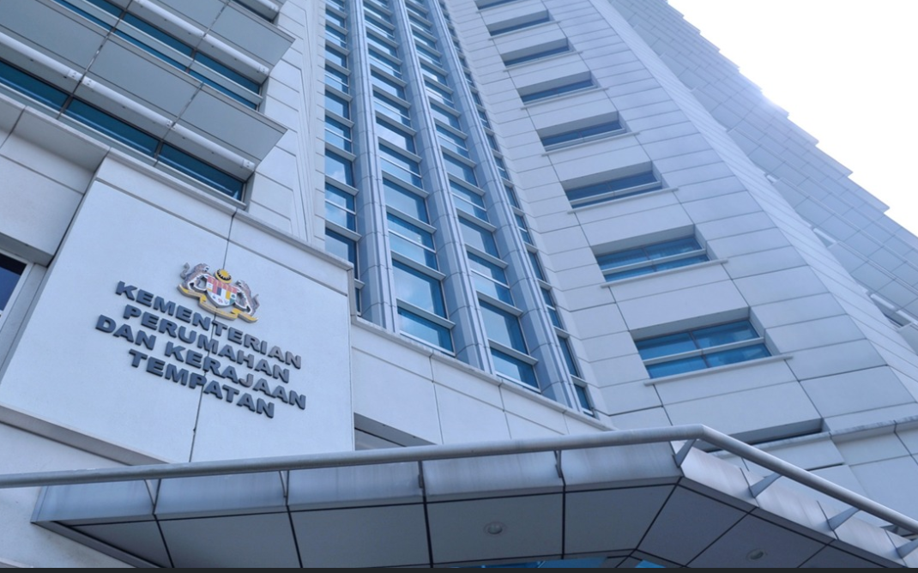

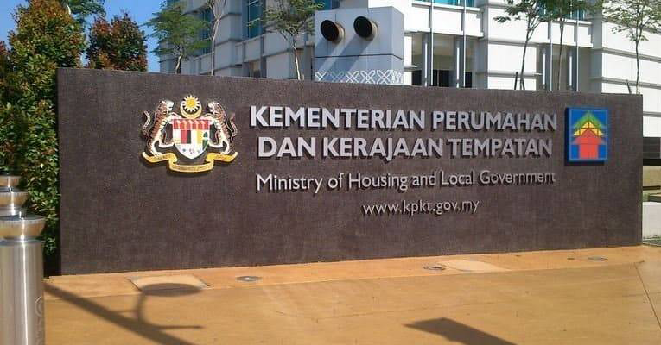

**How do we mainstream our Smart City Agenda in Malaysia?**   
As a Federal constitutional monarchy, the government in Malaysia is divided into three levels namely Federal, State and Local government. In corresponding to the government structure in Malaysia, spatial planning in Malaysia is also tiered into three levels.   
  
**Federal Level**   
At National Level, The Malaysia Smart City Framework has become the ‘text-book’ to guide the implementation of Smart City and compliment other national policies and strategies.   
  
**Regional and State Level**   
At Regional or State Level, many State have developed their Smart City Policies in the form of Smart City Blueprint that covered a state-wide strategies.   
  
**Local Level**   
 At the lowest level, we encourage the Local Government to formulate their own Smart City Action Plan to localised their smart city implementation guidance in systematic approach.  
  
**-PLANMalaysia-**

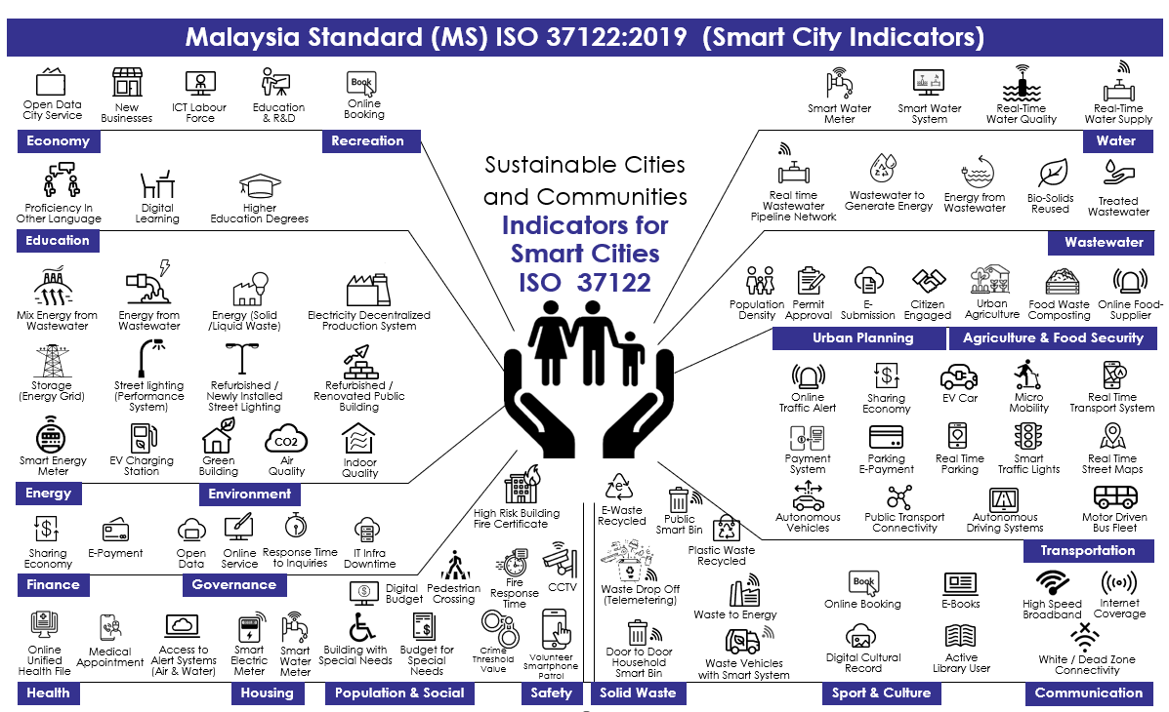

**SMART CITIES: DIGITAL SOLUTION FOR MORE LIVEABLE FUTURE**   
• Smart City Help Cities Fight Crime and Improve Other Aspects Of Public Safety   
• Smart City Make Daily Commutes Faster & Less Frustrating   
• Smart City Can Be Catalysts for Better Health   
• Smart City Deliver A Cleaner and More Sustainable Environment   
• Smart City Create A New Type of Digital Urban Commons and Enhance Social Connectedness   
• Smart City Can Make Local Labour Markets More Efficient   
• Smart City Can Lower The Cost of Living

As cities get smarter, they are becoming more liveable and more responsive and today we are seeing only a preview of what technology could eventually do in the urban environment.

After a decade of smart city implementation, city leaders are realizing that smart-city strategies start with people, not technology. “Smartness” is not just about installing digital interfaces in traditional infrastructure or streamlining city operations. It is also about using technology and data purposefully to make better decisions and deliver a better quality of life.



**References:**  
  
1. [www.malaysia.gov.my/](http://www.malaysia.gov.my/)

1. <https://www.kpkt.gov.my/>
2. <https://www.planmalaysia.gov.my/>
3. <https://mytownnet.planmalaysia.gov.my/>
4. <https://servicedev.planmalaysia.gov.my/>
5. [https://smartcity.johor.gov.my/](https://smartcity.johor.gov.my/johor-smart-city-2030-blueprint/)